ABSTRACT
This project focuses on visualizing housing market trends using Tableau to simplify complex real estate data and uncover meaningful insights. Housing data often includes numerous features like sale price, location, number of rooms, square footage, and year built—making manual analysis difficult for most users. By leveraging Tableau’s powerful visualization capabilities, this project transforms raw data into interactive dashboards that highlight patterns and relationships within the housing market.
The analysis includes time-based pricing trends, regional comparisons, and correlations between property features and sale prices. Users can explore the data through filters such as location, price range, and property size, allowing for a customized and insightful experience. The project supports real estate stakeholders—including buyers, sellers, and analysts—by providing a clear, data driven view of market dynamics.
Visual tools such as heatmaps, bar graphs, and line charts make it easier to identify trends and outliers quickly. While the solution is highly informative, it also faces challenges such as data quality issues and performance limitations with large datasets. Overall, the project bridges the gap between raw housing data and actionable insights, enabling smarter, evidence-based decision-making in the real estate sector.

Project Report Format

1. INTRODUCTION
1.1 Project Overview
1.2 Purpose

2. IDEATION PHASE
2.1 Problem Statement
2.2 Empathy Map Canvas
2.3 Brainstorming

3. REQUIREMENT ANALYSIS
3.1 Customer Journey map
3.2 Solution Requirement
3.3 Data Flow Diagram
3.4 Technology Stack

4. PROJECT DESIGN
4.1 Problem Solution Fit
4.2 Proposed Solution
4.3 Solution Architecture
- PROJECT PLANNING & SCHEDULING
  - Project Planning
- FUNCTIONAL AND PERFORMANCE TESTING
  - Performance Testing
- RESULTS
  - Output Screenshots

8. ADVANTAGES & DISADVANTAGES 9. CONCLUSION 10. FUTURE SCOPE 11. APPENDIX
Source Code(if any)
Dataset Link
GitHub & Project Demo Link

Project Report Format

- INTRODUCTION
  - Project Overview
This project seeks to visualize and examine housing market trends through interactive Tableau dashboards. Through the study of datasets with housing sales prices and corresponding features (e.g., number of bedrooms, square meters, location, year constructed), we reveal dominant patterns driving house prices. The visualizations assist in determining market hotspots, time-series pricing trends, and variability in prices by features. These observations facilitate data-driven decisions among homebuyers, sellers, and real estate agents. The initiative focuses on simple, interactive dashboards that expose high-level trends and detailed information about the housing market
  - Purpose
The aim of this project is to visualize and compare major housing market trends using Tableau in order to gain a better idea of how different property characteristics—location, size, number of rooms, etc.—impact prices. By bringing difficult data to life in interactive visualization dashboards, the aim is to deliver actionable insights to buyers, sellers, and real estate analysts to enable smarter decision-making.

- IDEATION PHASE

  - Problem Statement
The housing market produces a large amount of complex data, which is difficult to interpret without technical skills. Buyers often struggle to judge fair prices, sellers face challenges in setting competitive rates, and analysts need help identifying trends. Current tools lack clarity and visual insight into how home features impact prices. This gap limits smart decision-making in the real estate sector. A visual, interactive solution is needed to simplify and explore these trends effectively
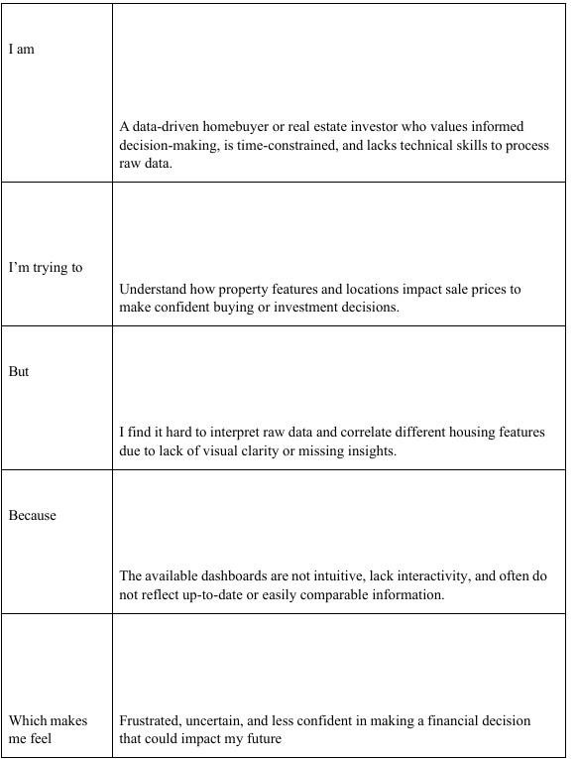

  - Empathy Map Canvas
Users see property listings, market reports, graphs, maps, and online tools that show housing prices and trends. They often deal with confusing or inconsistent data and rely on visual comparisons to understand the market and make decisions
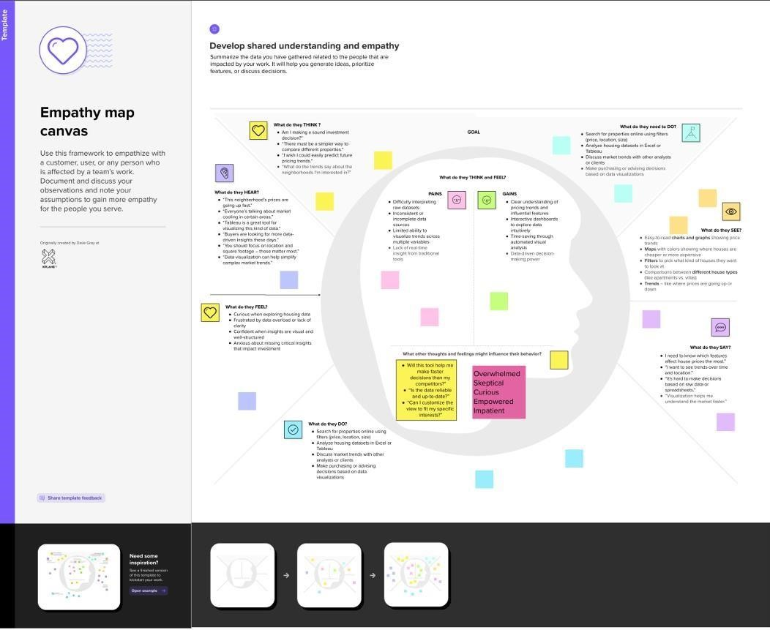
  - Brainstorming
The project will use housing datasets with features like price, location, and size to uncover trends. Key questions include how property features affect pricing and how prices vary by area and over time. Visual tools like heatmaps, bar charts, and filters will make insights clear and interactive. The goal is to support buyers, sellers, and analysts with easy-to-understand dashboards. Challenges may include handling missing data and designing user-friendly visuals. Step 1: Team Gathering, Collaboration and Select the Problem Statement Participants:
S.Gnana Prasanna, S.Anjali, U.Surendra Babu., We are all together connect through the ZOOM meeting and discuss about home trends and its problems Goal:
We aim to identify key house features affecting sale prices-like renovation year, age, rooms, floors, and visualize them using interactive Tableau dashboards to support better, data-driven decisions.

Problem Statement (How Might We…):
How might we design Tableau dashboards that uncover and clearly communicate key factors affecting house sale prices and trends across features like renovation, age, bedrooms, bathrooms, and floors?
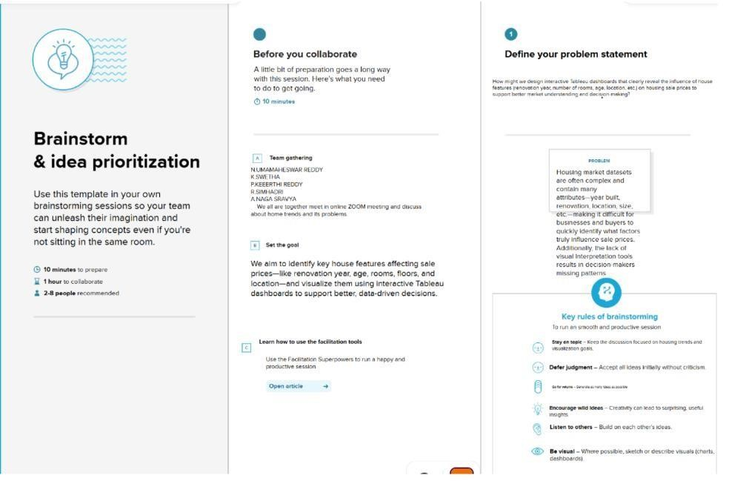
Step-2: Brainstorm, Idea Listing and Grouping:
Ideas List: -
Show average sale price over years since renovation - Correlate number of bathrooms with price - Cluster house age with number of floors - Heatmap of price distribution by zip code - Use filters for bedrooms/floors/bathrooms - Show trend lines by year built - Bar chart: average price by number of bedrooms - Compare renovated vs non-renovated price growth Grouped Clusters:

Cluster Theme | Idea
Renovation Impact | Show average price over years since renovation, compare renovated vs not
House Age & Structural Features | Cluster house age with floors, show trend lines by year built
Bathrooms/Bedrooms Impact | Correlate bathroom counts, average price by bedrooms
Location-based Price Analysis | Heatmap by zip code, regional filters
Dashboard Interactivity | Filters, dropdowns, slicers

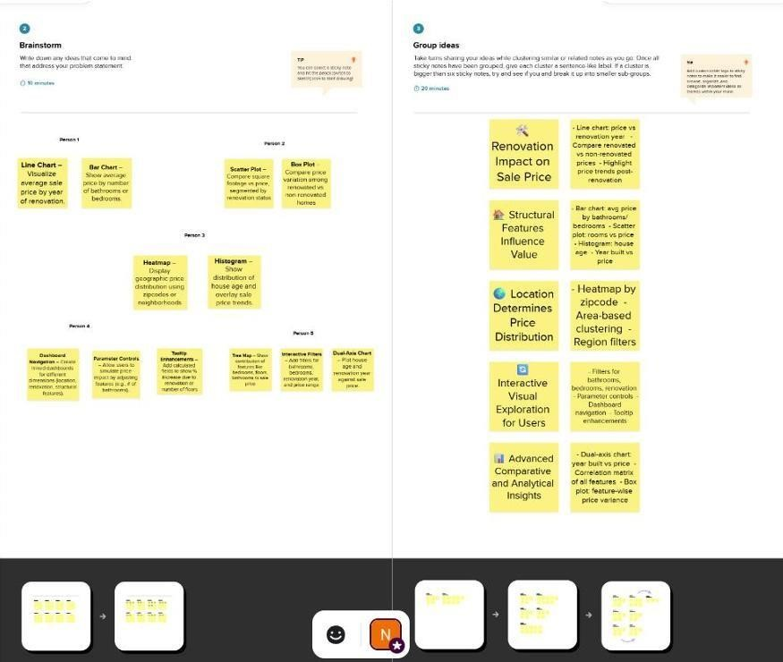
Step-3: Idea Prioritization
Idea Cluster | Feasibility | Importance | Final Priority
Renovation Impact | High | High | Top Priority
House Age &Structural Features | Medium | High | Priority 2
Bathrooms/Bedrooms  Impact | High | Medium | Priority 3
Location-based  Price Analysis | Medium | Medium | Optional/  Future Enhancement
Dashboard Interactivity High |  | High | Essential – include in all dashboards
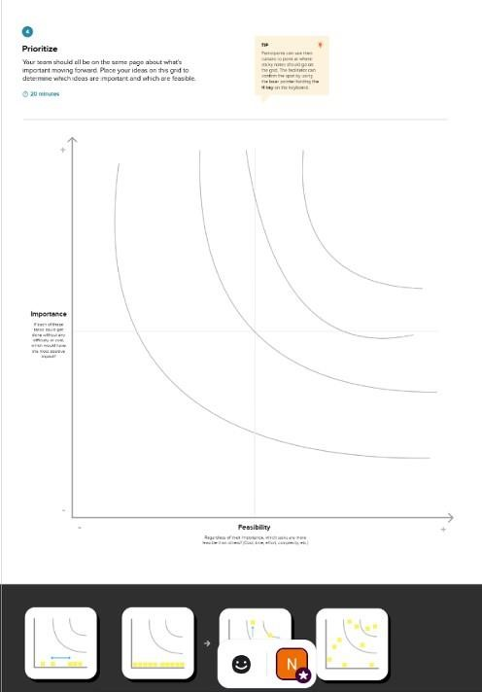

- REQUIREMENT ANALYSIS

  - Customer Journey map
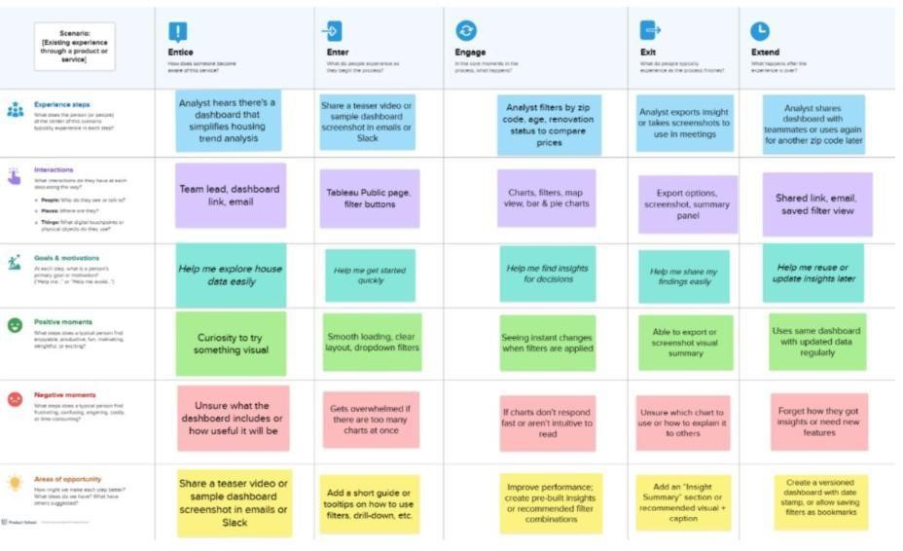
  - Solution Requirement
Functional Requirements:
Following are the functional requirements of the proposed solution.
FR No | Functional Requirement (Epic) | Sub Requirement (Story / Sub-Task)
FR  1 | Data Upload | Upload CSV/Excel of housing market  data
FR  2 | Data Cleaning | Remove missing or inconsistent values
FR  3 | Feature Engineering | Add derived metrics (e.g., price/sq. ft)
FR  4 | Interactive Visualization | Filter data by region, price range, features
FR  5 | Trend Analysis | Time-based trends in housing prices
FR  6 | Data Export | Export selected visual insights to image/PDF

Non-Functional Requirements:
Following are the non-functional requirements of the proposed solution.
NFR NO | Non-Functional Requirement | Description
NFR 1 | Usability | The dashboard must be intuitive and simple to use for non-technical users
NFR 2 | Security | Local-only access; data not shared externally; no login needed.
NFR 3 | Reliability | Should handle file errors and missing data gracefully.
NFR 4 | Performance | Should render visualizations for medium datasets (~10,000 records) quickly
NFR 5 | Availability | Works offline on local Tableau Desktop software
NFR 6 | Scalability | Suitable for scaling up to slightly larger datasets if needed in future

  - Data Flow Diagram:
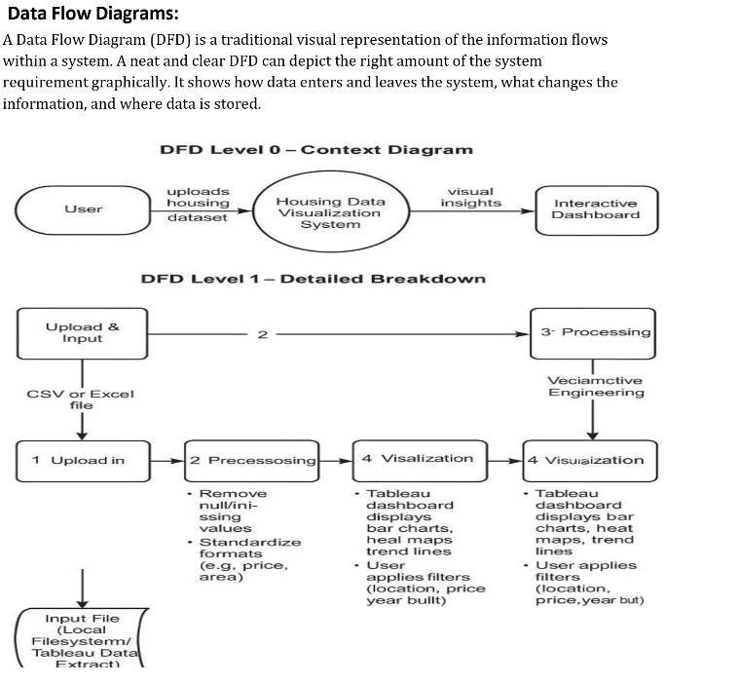
DFD Level 0 - Project Overview
    - User uploads the housing dataset (CSV/Excel)
    - Preprocessing Module (Python) cleans and transforms the data
    - Feature Engineering Module adds derived attributes (e.g., price/sq. ft)
    - Visualization Layer (Tableau Dashboard) displays trends and insights
    - User views or exports filtered insights
DFD Level 1- Detailed Process
    - Data Upload → File Validation → Missing Value Handling
    - Data Transformation → Unit Normalization → Column Derivations
    - Dashboard → Filters by Region, Price, Bedrooms, etc. → Displays Graphs and Charts

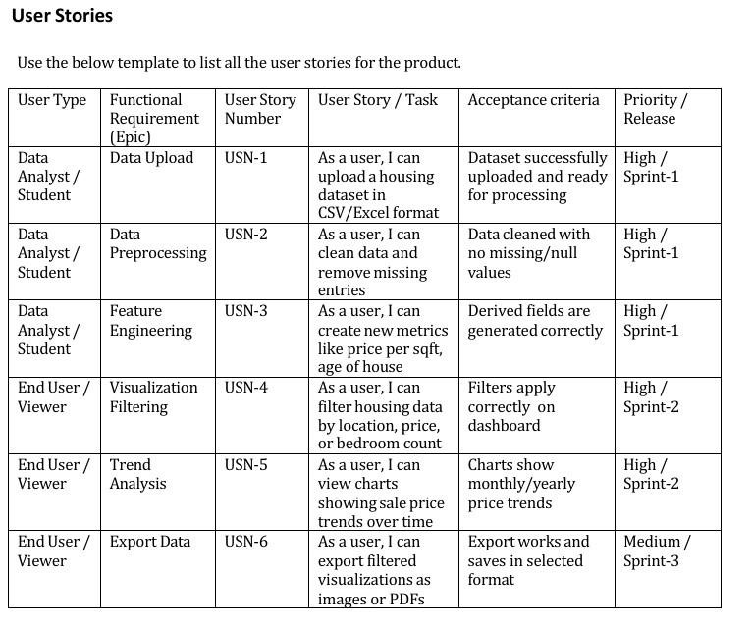

  - Technology Stack:
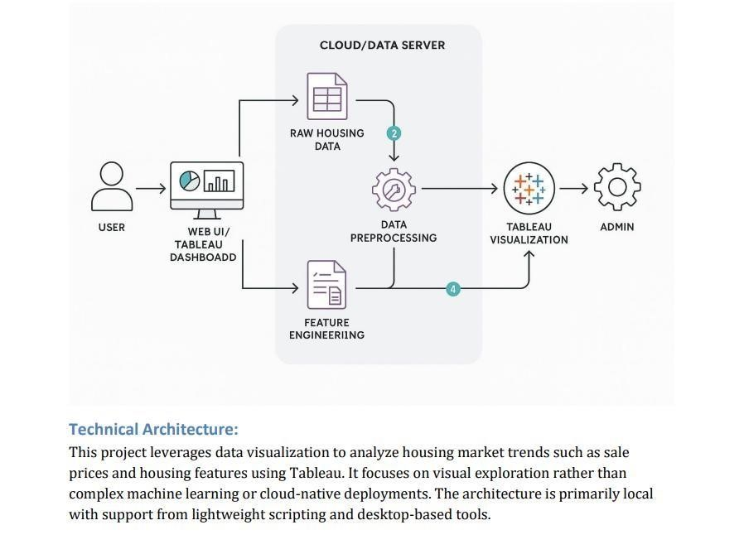
Architecture Diagram Summary:
- User Interface (Tableau Dashboard)- Users interact with visualizations.
- Data Source (Local File Storage) - CSV or Excel files used as input.
- Preprocessing (Python)- Data is cleaned and structured using pandas.
- Feature Engineering (Python or Tableau Prep)- Additional insights generated.
- Visualization Layer (Tableau Desktop / Public) - Interactive dashboards built and published.
- Infrastructure - Local machine for development and deployment.

Table-1: Components & Technologies:
S. No | Component | Description | Technology Used
1 | User Interface | Dashboard interface for user interaction | Tableau Public / Tableau Desktop
2 | Application Logic-1 | Preprocessing logic for housing data | Python (Pandas, NumPy)
3 | Application Logic-2 | Feature engineering and transformations | Tableau Prep / Python
4 | Application Logic-3 | Not Used | Not used
5 | Database | Raw data storage (optional, using files) | Not used / CSV
6 | Cloud Database | Not used in this project | Not used
7 | File Storage | For storing CSV/Excel input files | Local Filesystem
8 | External API-1 | Not used | Not used
9 | External API-2 | Not used | Not used
10 | Machine Learning Model | Not used | Not used
11 | Infrastructure | System where the application runs | Local Desktop  (Windows/Mac)

Table-2: Application Characteristics:
S. No | Characteristics | Description | Technology
1 | Open-Source  Frameworks | Data preprocessing and manipulation | Python (Pandas, NumPy)
2 | Security  Implementations | No user authentication or cloud data access in current version | Not Applicable
3 | Scalable  Architecture | Not designed for cloud scale or multiple users | Not Applicable
4 | Availability | Local system availability only | Tableau Desktop on personal system
5 | Performance | Handles small to medium datasets, processed locally using efficient libraries | Python (Pandas),  Tableau  Optimizations

- PROJECT DESIGN
  - PROBLEM FIT SOLUTION
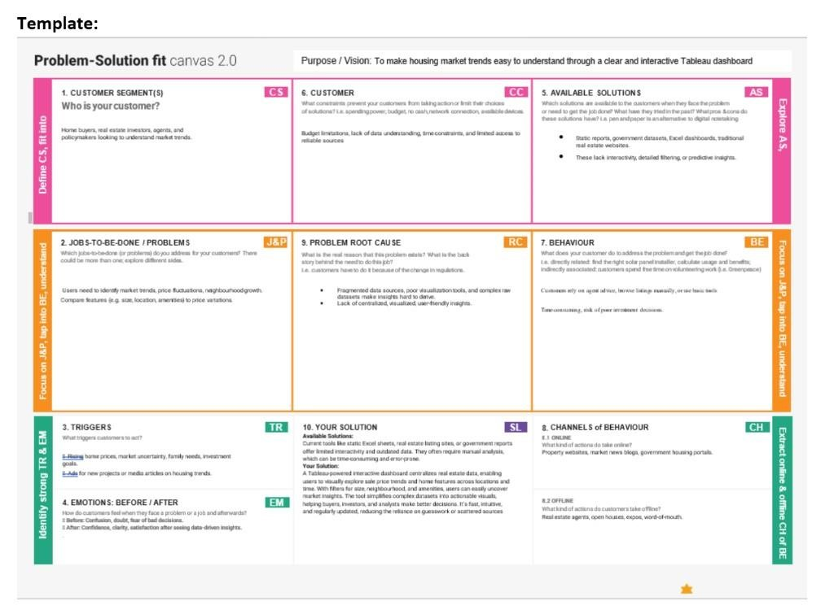

  - Proposed Fit Solution:
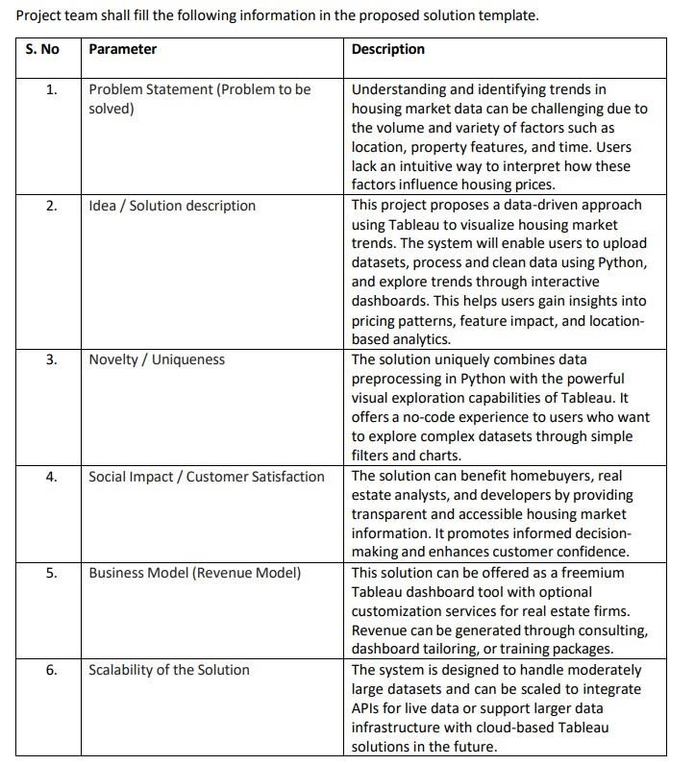

  - Solution Architecture:

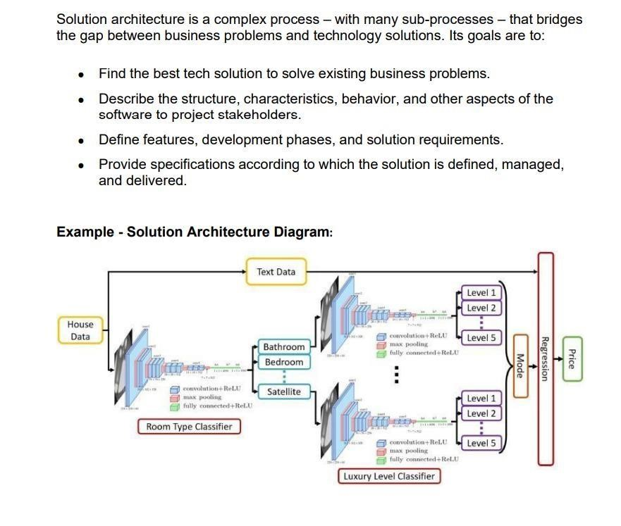

- PROJECT PLANNING & SCHEDULING
  - Project Planning

Product Backlog, Sprint Schedule, and Estimation (4 Marks)
Use the below template to create product backlog and sprint schedule

Sprint | Functional  Requirement  (Epic) | User Story  Number | User Story / Task | Story points | Priority | Team Members
Sprint-1 | Data Collection | USN-1 | As a user, I can upload a housing dataset in CSV/Excel format | 3 | High | C.Sarika
Sprint-1 | Data Loading | USN-2 | As a user, I can load the dataset into Tableau | 2 | High | K.Sravani, CH.Abhilash
Sprint-2 | Data Cleaning | USN-3 | As a user, I can clean data and remove missing entries | 3 | High | T. Sagar,  I. Akshay
Sprint-2 | Categorical Handling | USN-4 | As a user, I can preprocess categorical fields appropriately | 3 | High | C.Sarika
Sprint-3 | Dashboard Design | USN-5 | As a user, I can view visual summaries of pricing trends | 2 | High | K.Sravani, CH.Abhilash
Sprint-3 | Feature-based Filtering | USN 6 | As a user, I can filter dashboards by price, bedrooms, location, etc. | 2 | High | C.Sarika
Sprint-4 | Dashboard  Exporting | USN 7 | As a user, I can export  visuals to images or PDFs | 2 | High | K.Sravani, CH.Abhilash
Sprint-4 | Tableau Public Publishing | USN 8 | As a user, I can publish dashboards to Tableau Public | 1 | High | T. Sagar, I. Akshay

Project Tracker, Velocity & Burndown Chart: (4 Marks)

Sprint | Total  Story  Points | Duration | Sprint Start Date | Sprint End Date | Story Points  Completed (as on planned date) | Sprint Release Date  (Actual)
Sprint-1 | 5 | 2 Days | 15 FEB 2026 | 16 FEB 2026 | 5 | 17 FEB 2026
Sprint-2 | 5 | 2 Days | 16 FEB 2026 | 17 FEB 2026 | 5 | 18 FEB 2026
Sprint-3 | 5 | 2 Days | 16 FEB 2026 | 17 FEB 2026 | 5 | 18 FEB 2026
Sprint-4 | 5 | 1 Day | 17 FEB 2026 | 17 FEB 2026 | 5 | 18 FEB 2026
Sprint-5 | 5 | 1 Day | 17 FEB 2026 | 17 FEB 2026 | 5 | 18 FEB 2026

Velocity:
Imagine we have a 10-day sprint duration, and the velocity of the team is 20 (points per sprint). Let’s calculate the team’s average velocity (AV) per iteration unit (story points per day) Average velocity=5+5+5+5+5/2+2+2+1+1=25/8=3.12 Story points/day (rounded) Final average team velocity=3.1 points / day
Burndown Chart
A burndown chart visually represents the remaining work versus time.
You can manually plot this based on the dates and story point progression above using tools like Excel or Google Sheets.

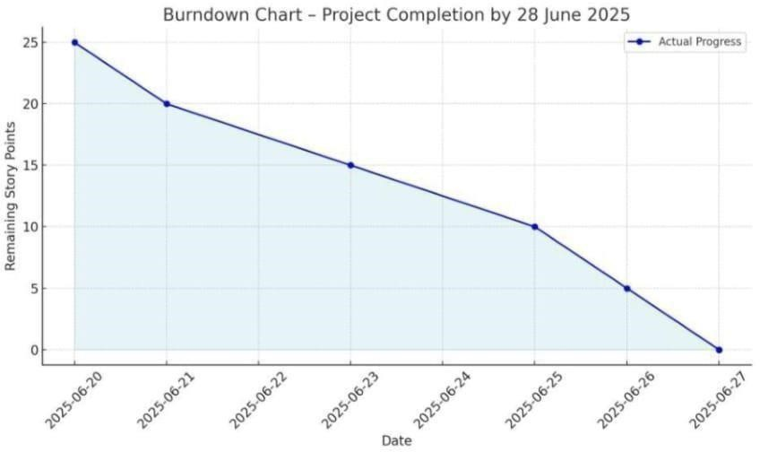

- FUNCTIONAL AND PERFORMANCE TESTING
  - Performance Testing
Model Performance Testing

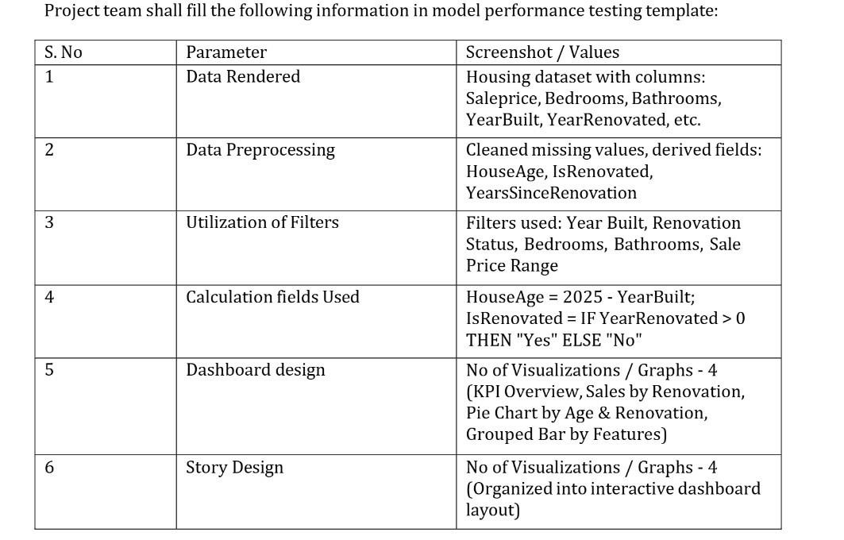

- RESULTS
  - Output Screenshots

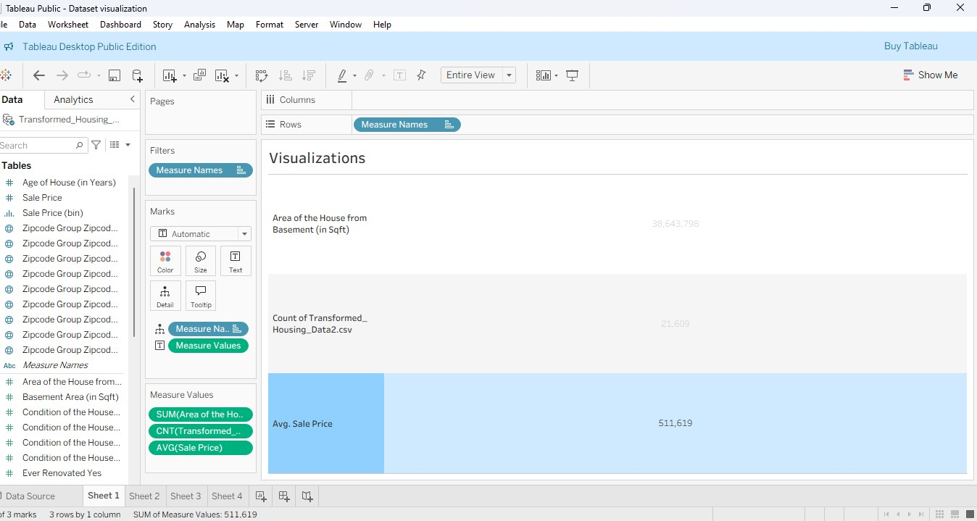
Fig 1: Overall Housing Data Overview.

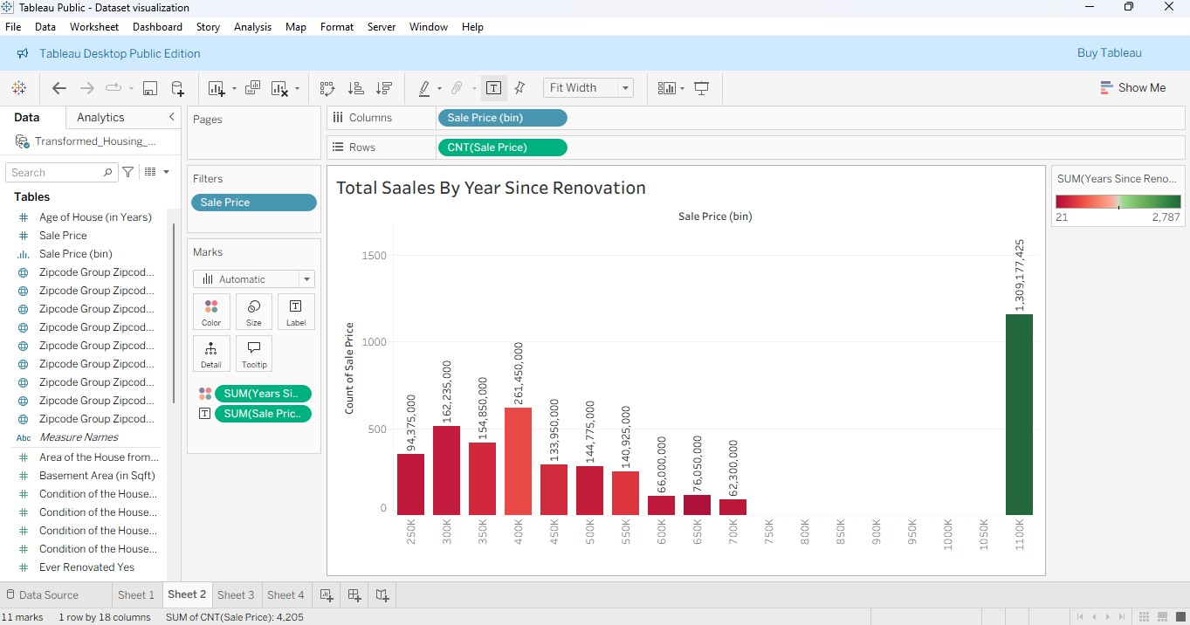
Fig 2: Total Sales by Years Since Renovation
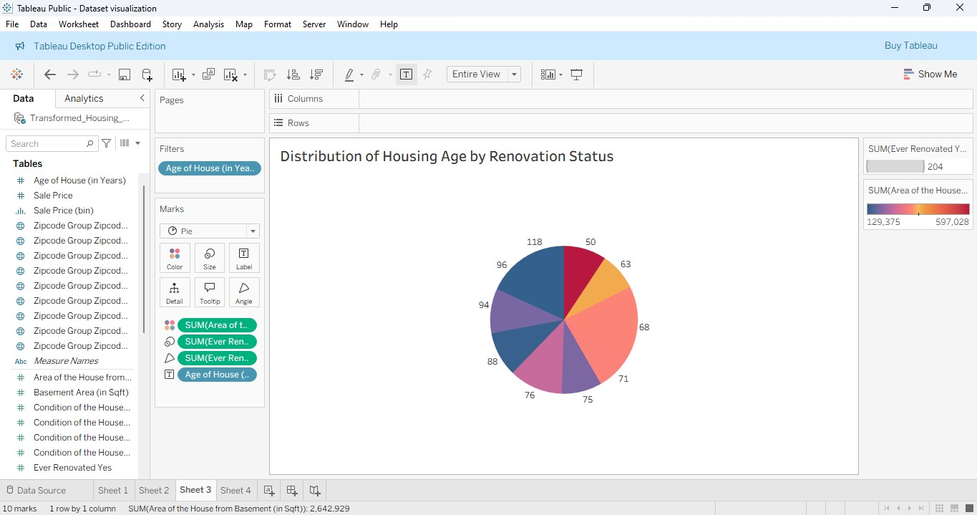
Fig 3 Distribution of House Age by Renovation Status
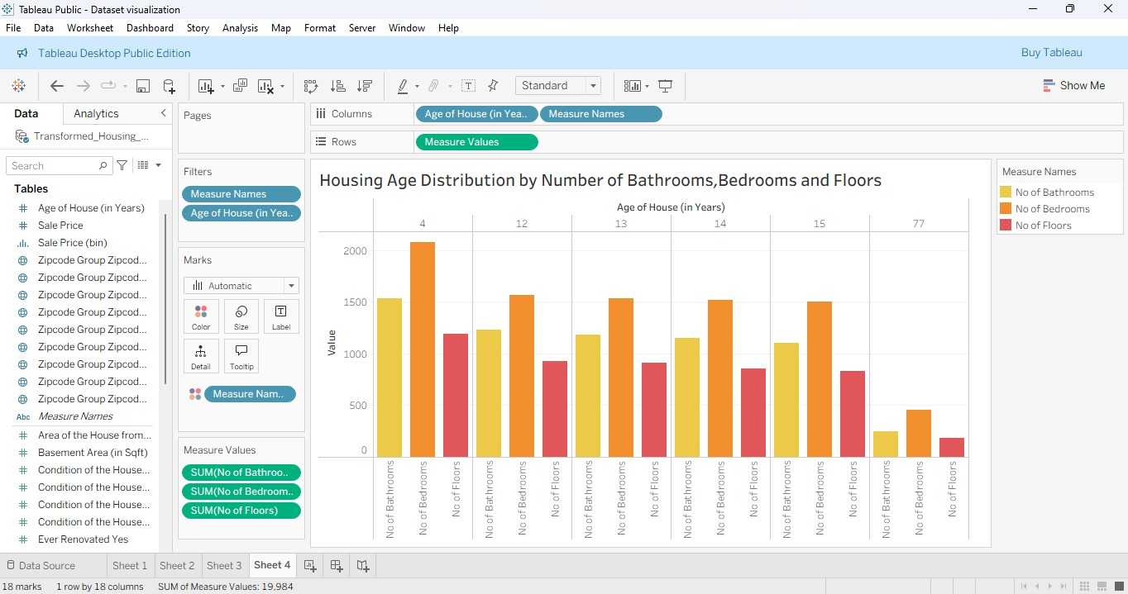
Fig 4 - House Age Distribution by Number of Bathrooms, Bedrooms, and Floors

- Advantages & Disadvantages:
  - Advantages
    - Easy to Understand – Visual dashboards make complex housing data easier for non-technical users to interpret.
    - Quick Insights – Users can instantly spot trends and patterns using filters, maps, and charts.
    - Better Decision-Making – Buyers and sellers can make informed decisions based on data-driven insights.
    - Customizable Views – Tableau allows interactive filtering by location, time, or property features.
    - Professional Appeal – Useful for real estate professionals and analysts for presentations or reports.

Disadvantages
    - Data Quality Issues – Incomplete or outdated data can affect accuracy.
    - Tool Limitation – Tableau requires a learning curve and may have limited free version features.
    - Performance Concerns – Large datasets may slow down dashboard responsiveness.
    - Dependence on Visualization – Users may rely on visuals without understanding deeper statistical relationships.
    - Access Restrictions – Not everyone may have access to Tableau software or licenses.

- CONCLUSION
This project successfully demonstrates how interactive data visualization can simplify complex real estate data and make housing market trends more accessible. By using Tableau, we analyzed key property features that impact sale prices and revealed patterns across time and location. The dashboards offer clear, actionable insights for homebuyers, sellers, and market analysts. Overall, the solution enhances understanding, supports smarter decision-making, and bridges the gap between raw housing data and meaningful interpretation.

- Future scope
    - Incorporate Real-Time Data – Integrate APIs or live data feeds to provide up-to-date market trends and price changes.
    - Predictive Analytics – Apply machine learning models to forecast future housing prices based on current trends.
    - Expand to Rental Market – Include rental listings and trends to serve a broader audience.
    - Mobile-Friendly Dashboards – Optimize dashboards for mobile users to increase accessibility.
    - User Personalization – Allow users to customize views based on preferences like location, budget, or property type.
    - Integration with External Tools – Connect Tableau dashboards with platforms like CRM or real estate listing sites for seamless workflow.
- APPENDIX
  - Dataset
Visualizing Housing Market Trends An Analysis of Sale Prices and Features using Tableau
https://www.kaggle.com/datasets/rituparnaghosh18/transformed-housing-data-2
  - GitHub:
https://github.com/PRASSU-2003/-Visualizing-Housing-Market-Trends-An-Analysis-of-Sale-Prices-And-Using-Tableau

